# BLOOD

# Physical properties of blood

* Weight = 8% of total body weight
* Volume = 5-6 L in males & 4-5 L in females
* Colour - depends on hemoglobin oxygenation
* oxygenated its red.
* Deoxygenated dark blue.
* PH = 7.35 – 7.45
* Viscosity > water.

# Blood composition

# 

* When a blood sample is prevented from clotting and spun in a centrifuge tube, it forms two layers.
* The yellow top layer is plasma, the liquid portion of blood.
* The formed elements are in the bottom layer
* The white blood cells forms mid layer (note the buffy layer), (less than 1%)
* The percentage of blood attributed to red blood cells is called the **hematocrit.**

# BLOOD PLASMA

[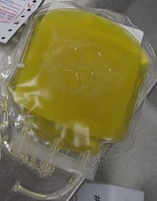](https://en.wikipedia.org/wiki/File:FreshFrozenPlasma.JPG)

A unit of donated [fresh plasma](https://en.wikipedia.org/wiki/Fresh_plasma)

* **Blood plasma** is a yellowish liquid component of blood that holds the [blood cells](https://en.wikipedia.org/wiki/Blood_cell) in [suspension](https://en.wikipedia.org/wiki/Suspension_(chemistry)). It is the liquid part of the blood that carries cells and proteins throughout the body.
* It is mostly water (up to 95% by volume), and contains dissolved [proteins](https://en.wikipedia.org/wiki/Protein) (6–8%) (e.g. [serum albumins](https://en.wikipedia.org/wiki/Serum_albumin), [globulins](https://en.wikipedia.org/wiki/Globulin), and [fibrinogen](https://en.wikipedia.org/wiki/Fibrinogen)), [glucose](https://en.wikipedia.org/wiki/Glucose), [clotting factors](https://en.wikipedia.org/wiki/Clotting_factors), [electrolytes](https://en.wikipedia.org/wiki/Electrolyte) (Na+, Ca2+, Mg2+, HCO3−, Cl−, etc.), [hormones](https://en.wikipedia.org/wiki/Hormone), [carbon dioxide](https://en.wikipedia.org/wiki/Carbon_dioxide) (plasma being the main medium for excretory product transportation) and [oxygen](https://en.wikipedia.org/wiki/Oxygen).
* Blood plasma is separated from the blood by [spinning a tube of fresh blood](https://en.wikipedia.org/wiki/Blood_fractionation) containing an [anticoagulant](https://en.wikipedia.org/wiki/Anticoagulant) in a [centrifuge](https://en.wikipedia.org/wiki/Centrifuge) until the blood cells fall to the bottom of the tube. The blood plasma is then poured or drawn off.
* [Blood serum](https://en.wikipedia.org/wiki/Blood_serum) is blood plasma without clotting factors

**Function of plasma proteins**

* **Transportation.**
  + Both albumins and globulins combine with and transport large organic molecules.
  + They bind
    - Hormones (e.g steroids and amine
    - Drugs
    - Metabolites (albumin transports the molecule bilirubin
* **Forming osmotic pressure.**
  + Albumin maintains osmotic pressure in blood
* **Coagulation and anticoagulation**
  + Fibrinogen (and also a protein called prothrombin) are necessary to coagulation (blood clotting).
* **Maintain pH value** 
  + They are able to take up and release hydrogen ions (buffering)
* **Immunity (globulin).**

**BLOOD CELLS, TYPES AND FUNCTIONS**

* Blood cells are the cells which are produced during hematopoiesis and found mainly in the blood.
* Blood is composed of the blood cells which accounts for **45%** of the blood tissue by volume, with the remaining **55%** of the volume composed of plasma, the fluid portion of the blood.

There are three types of blood cells. They are:

1. Red blood cells (Erythrocytes)
2. White blood cells (Leukocytes)
3. Platelets (Thrombocytes)

1. Red Blood Cells (Erythrocytes)

* Most abundant cells in the blood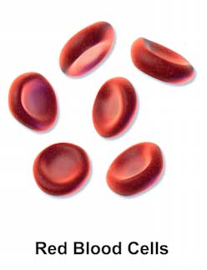
* Account for approximately 40 to 45 percent of the blood.
* Biconcave in shape, round and flat (like a shallow bowl.)
* They have a thick rim and a thin sunken center.
* Nucleus is Absent.
* Can change shape without breaking.
* Production of RBCs is controlled by erythropoietin.
* RBC contains hemoglobin, which contains iron.
* The iron found in hemoglobin gives the blood its red color.
* RBCs cannot repair themselves.
* Life span of 120 days.
* 4 million new erythrocytes are produced per second in human adults.

**Functions**

1. Transport oxygen from the lungs to the cells of the body.(using hemoglobin)
2. Pick up carbon dioxide from other tissues and unload it in the lungs. (using hemoglobin)

2. White Blood Cells (Leukocytes)

* Account for only about 1% of the blood.
* They are the cells that make up the majority of the **immune system.**
* They are made in the bone marrow from **hematopoietic stem cells.**
* They exist in all parts of the body, including the connective tissue, lymph system, and the bloodstream.
* They are divided into 2:

1. **Granulocytes** (having visible granules or grains inside the cells)
2. **Agranulocytes** (free of visible grains under the microscope).

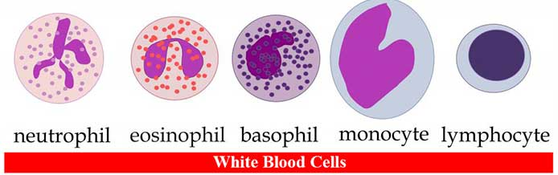

* There are five main types of WBCs.:

1. Neutrophils (granulocytes),
2. Eosinophils (granulocytes),
3. Basophils (granulocytes),
4. Lymphocytes (Agranulocytes)
5. Monocytes (Agranulocytes).

**Functions of neutrophils (**The most common type of white blood cell**)**

1. Kills bacteria through the process of **phagocytosis.**

**Functions of eosinophils**

1. **Kills parasites** and have a role in **allergic reactions.**
2. Releases toxins from their granules to kill pathogens.

**Functions of basophils**

1. Functions in allergic reactions.
2. Secrete anticoagulants and antibodies that have function against hypersensitivity reactions in the bloodstream.
3. Basophils contain histamine, which dilates the vessels to bring more immune cells to the area of injury.

**Functions of lymphocytes**

1. T lymphocytes (T cells) are responsible for cell-mediated immunity.
2. B lymphocytes are responsible for humoral immunity or antibody production.
3. They can recognize and have a memory of invading bacteria and viruses.
4. Function in destroying cancer cells.
5. They present antigens to activate other cells of the immune system.

**Functions of monocytes**

1. Enters tissue, where they become larger and turn into macrophages.
2. Destroy old, damaged and dead cells in the body.

3. Platelets (Thrombocytes)

* Nucleus Absent.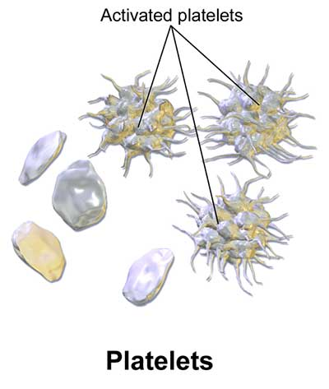

**Functions**

1. Platelets are sections of blood cells that are used for **clotting**. (major function)
2. Helps to promote other blood clotting mechanisms. Example: Secrete clotting factors to promote blood clotting.
3. They secrete vasoconstrictors which constrict blood vessels, causing vascular spasms in broken blood vessels.

**HEMOSTASIS**

* **Hemostasis** [or](https://en.wikipedia.org/wiki/American_and_British_English_spelling_differences#ae_and_oe) **haemostasis** is a process to prevent and stop [bleeding](https://en.wikipedia.org/wiki/Bleeding), meaning to keep [blood](https://en.wikipedia.org/wiki/Blood) within a damaged [blood vessel](https://en.wikipedia.org/wiki/Blood_vessel)
* The opposite of hemostasis is [hemorrhage](https://en.wikipedia.org/wiki/Bleeding).
* It is the first stage of [wound healing](https://en.wikipedia.org/wiki/Wound_healing).
* This involves [coagulation](https://en.wikipedia.org/wiki/Coagulation), blood changing from a liquid to a gel.
* Hemostasis has three major steps:

1) vasoconstriction,

2) temporary blockage of a break (injury) by a [platelet plug](https://en.wikipedia.org/wiki/Platelet_plug),

3) blood coagulation, or formation of a fibrin clot. These processes seal the hole until tissues are repaired.

Hemostasis is maintained in the body via three mechanisms:

1. [**Vascular spasm**](https://en.wikipedia.org/wiki/Vascular_spasm)**(Vasoconstriction) –**
   * Vasoconstriction is produced by vascular smooth muscle cells, and is the blood vessel's first response to injury.
   * The smooth muscle cells are controlled by vascular endothelium, which releases intravascular signals to control the contracting properties.
   * The damaged vessels will constrict (vasoconstrict) which reduces the amount of blood flow through the area and **limits the amount of blood loss.**
   * Vascular spasm is much more effective in smaller blood vessels
2. **Platelet plug formation-**
   * [Platelets](https://en.wikipedia.org/wiki/Platelet) adhere to damaged endothelium to form a platelet plug.
   * Plug formation is activated by a [glycoprotein](https://en.wikipedia.org/wiki/Glycoprotein) called [Von Willebrand factor](https://en.wikipedia.org/wiki/Von_Willebrand_factor) (vWF), which is found in [plasma](https://en.wikipedia.org/wiki/Blood_plasma). Platelets play one of major roles in the hemostatic process. When platelets come across the injured endothelium cells, they change shape, release granules and ultimately become ‘sticky’.
   * This process is referred to as **primary hemostasis**
3. **Clot formation –**
   * Once the platelet plug has been formed by the platelets, the [clotting factors](https://en.wikipedia.org/wiki/Clotting_factors) (blood proteins that travel along the plasma in an inactive state) are activated in a sequence of events known as 'coagulation cascade' which leads to the formation of [Fibrin](https://en.wikipedia.org/wiki/Fibrin) from inactive fibrinogen (a plasma protein).
   * Thus, a [Fibrin](https://en.wikipedia.org/wiki/Fibrin) mesh is produced all around the platelet plug to hold it in place; this step is called **"Secondary Hemostasis".**
   * During this process some red and white blood cells are trapped in the mesh which causes the primary hemostasis plug to become harder: the resultant plug is called as 'thrombus' or 'Clot'.
   * Therefore, 'blood clot' contains secondary hemostasis plug with blood cells trapped in it.

**BLOOD TYPE (BLOOD GROUPS)**

[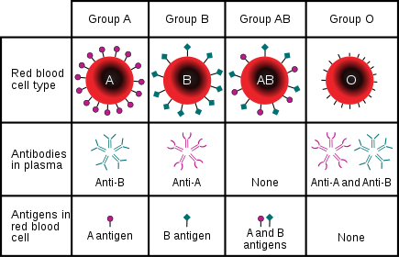](https://en.wikipedia.org/wiki/File:ABO_blood_type.svg)

Blood type (or blood group) is determined, by the ABO blood group antigens present on red blood cells.

* A **blood type** (also called a **blood group**) is a classification of [blood](https://en.wikipedia.org/wiki/Blood), based on the presence and absence of [antibodies](https://en.wikipedia.org/wiki/Antibodies) and [inherited](https://en.wikipedia.org/wiki/Heredity) [antigenic](https://en.wikipedia.org/wiki/Antigen) substances on the surface of [red blood cells](https://en.wikipedia.org/wiki/Red_blood_cell) (RBCs).
* Blood types are inherited and represent contributions from both parents. A total of 36 [human blood group systems](https://en.wikipedia.org/wiki/Human_blood_group_systems) and 346 antigens are now recognized by the [International Society of Blood Transfusion](https://en.wikipedia.org/wiki/International_Society_of_Blood_Transfusion)
* The two most important blood group systems are [ABO](https://en.wikipedia.org/wiki/ABO_blood_group_system) and [Rh](https://en.wikipedia.org/wiki/Rh_blood_group_system); they determine someone's blood type (A, B, AB, and O, with +, − or null denoting RhD status) for suitability in [blood transfusion](https://en.wikipedia.org/wiki/Blood_transfusion).

Blood group systems

* Almost always, an individual has the same blood group for life, but very rarely an individual's blood type changes through addition or suppression of an antigen in [infection](https://en.wikipedia.org/wiki/Infection), [malignancy](https://en.wikipedia.org/wiki/Malignancy), or [autoimmune disease](https://en.wikipedia.org/wiki/Autoimmune_disease).
* Another more common cause of blood type change is a [bone marrow transplant](https://en.wikipedia.org/wiki/Bone_marrow_transplant). Bone-marrow transplants are performed for [leukemias](https://en.wikipedia.org/wiki/Leukemias" \o "Leukemias), among other diseases.
* **If a person receives bone marrow from someone who is a different ABO type (e.g., a type A patient receives a type O bone marrow), the patient's blood type will eventually convert to the donor's type.**

1. **ABO blood group system**

* The ABO blood group system involves two antigens and two antibodies found in human blood.
* The two antigens are antigen A and antigen B.
* The two antibodies are antibody ***a*** and antibody ***b.***
* The antigens are present on the red blood cells and the antibodies in the serum.
* Regarding the antigen property of the blood all human beings can be classified into 4 groups, those with antigen A (group A), those with antigen B (group B), those with both antigen A and B (group AB) and those with neither antigen (group O).
* The antibodies present together with the antigens are found as follows:

1. Antigen A with antibody b
2. Antigen B with antibody a
3. Antigen AB has no antibodies
4. Antigen nil (group O) with antibody a and b.

* There is an [agglutination](https://en.wikipedia.org/wiki/Agglutination_(biology)) reaction between similar antigen and antibody (for example, antigen A agglutinates the antibody a and antigen B agglutinates the antibody b).
* Thus, transfusion can be considered safe as long as the serum of the recipient does not contain antibodies for the blood cell antigens of the donor.

**\*The *ABO system* is the most important blood-group system in human-blood transfusion.**

1. **Rh blood group system**

* The Rh system (Rh meaning [*Rhesus*](https://en.wikipedia.org/wiki/Rhesus_macaque)) is the second most significant blood-group system in human-blood transfusion.
* The most significant Rh antigen is the D antigen, because it is the most likely to provoke an immune system response of the five main Rh antigens.
* It is common for D-negative individuals not to have any anti-D antibodies, because anti-D antibodies are not usually produced by sensitization against environmental substances.
* Rh0 (D) immune globulin is a medication given both during and following birth (upto 72 hrs) used to prevent RhD isoimmunization in mothers who are rhesus negative
* In other words, anti D injection will destroy any RhD positive blood cells that may have crossed over into the mother’s bloodstream during delivery. This means the mother’s blood won’t have a chance to produce antibodies, and will significantly reduce the risk of the next baby having rhesus disease
* Rhesus disease is a condition where antibodies in a pregnant woman’s blood destroys her baby’s blood cells (causing HDFN)